

SafeSea: SDG-Based Smart Maritime Boundary Protection and Environmental Monitoring System Using Object-Oriented Analysis and Design

A CAPSTONE PROJECT REPORT

A Capstone Project Report submitted in partial fulfilment of the requirements for the Course of

CSA1110- OBJECT ORIENTED ANALYSIS AND DESIGN

to the award of the degree of

BACHELOR OF ENGINEERING

IN
COMPUTER SCIENCE AND ENGINEERING

Submitted by
Tejaswini. M(192411079)

Under the Supervision of
Dr Manimaran A
SIMATS ENGINEERING
Saveetha Institute of Medical and Technical Sciences Chennai-602105

SEPTEMBER 2026

SIMATS ENGINEERING
Saveetha Institute of Medical and Technical Sciences Chennai-602105

BONAFIDE CERTIFICATE

This is to certify that the Capstone Project entitled “SafeSea: SDG-Based Maritime Boundary Protection and Environmental Monitoring System Using Object Oriented Analysis And Design” has been carried out by Tejaswini. M (192411079) under the supervision of Dr Manimaran A and is submitted in partial fulfilment of the requirements for the current semester of the B.E Computer Science and Engineering program at Saveetha Institute of Medical and Technical Sciences, Chennai.

COURSE COORDINATOR COURSE FACULTY
Dr Ramamurthy, Dr Manimaran A,
Professor Professor
Department of CSE Department of CSE
SIMATS Engineering, SIMATS Engineering,
SIMATS, Chennai – 602105. SIMATS, Chennai – 602105.

SIMATS ENGINEERING
Saveetha Institute of Medical and Technical Sciences Chennai-602105

DECLARATION

I, Tejaswini. M of the Department of CSE, SIMATS Engineering, Saveetha Institute of Medical and Technical Sciences, Chennai, hereby declare that the Capstone Project Work entitled “SafeSea: SDG-Based Maritime Boundary Protection and Environmental Monitoring System Using Object Oriented Analysis And Design” is the result of my own bonafide efforts. To the best of my knowledge, the work presented herein is original, accurate, and has been carried out in accordance with the principles of engineering ethics and academic integrity.All sources, references, data, and other materials used in the project have been appropriately acknowledged. I further declare that the data, results, analysis, and findings presented in this report have not been fabricated, falsified, or manipulated. Any external tools, software, datasets, computational resources, or AI-assisted tools used during the project have been appropriately disclosed. I confirm that all applicable ethical, academic, institutional, and professional requirements have been duly followed throughout the planning, execution, analysis, and documentation of the project.

Place: Thandalam, Chennai
Date: 08/09/2026

Signature of the Students with Names

Tejaswini. M (192411079)

SIMATS ENGINEERING
Saveetha Institute of Medical and Technical Sciences Chennai-602105

Individual Contribution Statement

Student Name / Register No. | Specific Responsibilities | Design & Development Contribution | Testing & Analysis Contribution | Report Contribution | Approx. Contribution (%)
Tejaswini M (192411079) | Navigation and safe route management | Navigation interface, GPS/map and route-management features | Navigation and route testing | System design, navigation and UI sections | 25%
Sharu Priya M (192411116) | Fisherman registration and voyage management | Registration, authentication and voyage management features | Login, registration and voyage testing | Introduction, requirements and registration sections | 25%
Vishalsai BJ (192320012) | Boundary monitoring and emergency communication | Boundary detection, alerts, SOS and emergency communication | Boundary, alert and SOS testing | Boundary, emergency communication and testing sections | 25%
D Chaitanya (192320028) | Navigation analytics and system evaluation | Analytics, reporting and evaluation features | Performance and system evaluation | Analytics, OOAD diagrams and conclusion | 25%
Total | — | — | — | — | 100%

ABSTRACT

SafeSea is a smart maritime safety and navigation system designed to support fishermen in safer route planning, boundary monitoring, and emergency response. Fishermen may face difficulties in identifying restricted maritime areas, monitoring vessel positions, selecting safer routes, and responding quickly to hazardous situations. These challenges can increase navigation risks and may lead to accidental entry into restricted zones.
The proposed system addresses these problems through an object-oriented software design that integrates fisherman registration, voyage management, navigation monitoring, safe route management, maritime boundary and hazard detection, emergency communication, and navigation analytics. The system follows Object-Oriented Analysis and Design (OOAD) principles to identify system actors, objects, classes, relationships, and interactions. Use case, class, activity, and other design models are used to represent the system structure and behaviour before implementation.
The system provides a centralized platform where fishermen can register their details, manage voyages, monitor their navigation position, and receive boundary or hazard alerts. It also supports emergency communication by transmitting vessel location and emergency information to appropriate response personnel. Navigation analytics and reporting features provide useful information for reviewing voyage activities and system performance.
The developed system was tested through functional and workflow-based verification of major features, including registration, authentication, navigation monitoring, boundary alerts, emergency communication, and analytics. The testing confirmed that the major system functions operated according to their intended requirements.
Overall, SafeSea demonstrates how OOAD can be applied to develop a structured maritime navigation and safety solution. The system provides an integrated approach to navigation assistance, boundary awareness, hazard notification, and emergency support, while establishing a foundation for future enhancements such as real-time data integration, improved route optimization, GIS-based visualization, and mobile support.

Keywords : SafeSea, Fisherman Navigation, Maritime Safety, Boundary Monitoring, OOAD, Emergency Communication, Hazard Detection

TABLE OF CONTENTS

Sl. No. | Title | Page No.
i | Certificate from the Supervisor | ii
ii | Declaration by the Candidate | iii
iii | Individual Contribution Statement | iv
iv | Abstract | v
v | List of Figures | vi
vi | List of Tables | vii
vii | List of Abbreviations / Symbols | viii
1 | CHAPTER 1: INTRODUCTION AND ENGINEERING PROBLEM | 1
2 | CHAPTER 2: LITERATURE REVIEW AND EXISTING SOLUTIONS | 4
3 | CHAPTER 3: ENGINEERING DESIGN & TRADE-OFFS, SUSTAINABILITY, ETHICS, SAFETY, RISK & SECURITY | 7
4 | CHAPTER 4: IMPLEMENTATION, TESTING & RESULTS, PROJECT MANAGEMENT | 15
5 | CHAPTER 5: CONCLUSION, FUTURE WORK AND REFLECTION | 23
 | References | 29
 | Appendices | 30

LIST OF FIGURES

Figure No. | Figure Name | Page No.
Figure 3.1 | SafeSea System Architecture | 12
Figure 4.1 | Login Page | 16
Figure 4.2 | Dashboard Page | 16
Figure 4.3 | Danger Alert | 17
Figure 4.4 | SafeSea Functional Testing Results | 19
Figure 4.5 | SafeSea Project Development Timeline | 22

LIST OF TABLES

Table No. | Table Name | Page No.
Table 1.1 | Existing Problems and Proposed SafeSea Solution | 1
Table 1.2 | Objectives and Expected Outcomes | 2
Table 3.1 | Stakeholder / User Requirements | 7
Table 3.2 | Functional and Non-Functional Requirements | 8
Table 3.3 | Constraints and Applicable Standards | 9
Table 3.4 | Design Specifications | 10
Table 3.5 | Alternative Solutions Evaluation Matrix | 11
Table 3.6 | Trade-off Analysis | 13
Table 3.7 | Sustainability, Ethics, Safety and Security Considerations | 14
Table 3.8 | SafeSea Risk Register | 14
Table 4.1 | Resources Used | 15
Table 4.2 | Tools Used | 16
Table 4.3 | Functional Test Plan | 17
Table 4.4 | Specification Verification | 18
Table 4.5 | Test Results Summary | 19
Table 4.6 | Achievement of Project Objectives | 20
Table 4.7 | Team Roles and Contributions | 22
Table 4.8 | Project Budget | 22

LIST OF ABBREVIATIONS / SYMBOLS

Abbreviation / Symbol | Description | Unit
OOAD | Object-Oriented Analysis and Design | —
GPS | Global Positioning System | —
GNSS | Global Navigation Satellite System | —
SOS | Save Our Souls / Emergency Signal | —
GIS | Geographic Information System | —
UI | User Interface | —
API | Application Programming Interface | —
RBAC | Role-Based Access Control | —
$d$ | Distance between two geographical points | km
$R$ | Earth's radius | km
$ϕ$ | Latitude | Degrees
$λ$ | Longitude | Degrees

CHAPTER 1
INTRODUCTION AND ENGINEERING PROBLEM
1.1 Background
Maritime fishing involves continuous movement of vessels through open water, where fishermen need to know their location, follow safe routes, and avoid restricted or hazardous areas. Manual monitoring can make it difficult to identify boundary violations and respond quickly during emergencies.
SafeSea is a smart maritime navigation and safety system designed to support fishermen during voyages. The system combines fisherman registration, voyage management, navigation monitoring, safe route management, boundary and hazard detection, emergency communication, and navigation analytics. The system is designed using Object-Oriented Analysis and Design (OOAD) principles to represent users, system objects, interactions, and relationships clearly.
1.2 Need for the Project
Fishermen may face navigation risks such as entering restricted maritime areas, encountering hazardous conditions, or experiencing emergencies during voyages. A system is therefore needed to provide timely navigation information and safety support.
The main limitations of existing manual approaches are:
- Difficulty in continuously monitoring vessel location.
- Risk of entering restricted or unsafe areas.
- Limited support for safe route planning.
- Delayed emergency communication.
- Difficulty in maintaining voyage history and analysing navigation activities.
SafeSea provides an integrated software solution to improve navigation awareness, boundary monitoring, and emergency response.

Existing Problem | SafeSea Solution
Difficulty monitoring vessel location | Navigation monitoring
Entry into restricted areas | Boundary detection and alerts
Unsafe route selection | Safe route management
Delayed emergency communication | SOS and emergency alerts
Limited voyage records | Voyage management and history
Difficulty reviewing navigation activities | Analytics and reporting
Table 1.1: Existing Problems and Proposed SafeSea Solution
1.3 Problem Statement
Fishermen require a reliable system to manage voyages, monitor vessel locations, identify restricted or hazardous areas, select safer routes, and communicate during emergencies. The engineering challenge is to integrate these functions into a single system while maintaining usability, accurate location-based monitoring, timely alerts, secure access, and reliable system operation under practical navigation conditions.
1.4 Project Aim
The aim of SafeSea is to design and develop an object-oriented maritime navigation and safety system that supports fishermen through navigation monitoring, safe route management, boundary and hazard detection, emergency communication, and navigation analytics.
1.5 Project Objectives
- To design a structured maritime navigation system using OOAD principles.
- To develop fisherman registration and voyage management functions.
- To implement navigation monitoring and safe route management.
- To provide boundary and hazard detection with appropriate alerts.
- To implement emergency communication and SOS support.
- To develop navigation analytics and reporting features.
- To test and evaluate the major system functions.

Objective | Expected Outcome
Design using OOAD | Structured system models
Develop registration and voyage management | User and voyage management
Implement navigation monitoring | Vessel location awareness
Detect boundaries and hazards | Safety alerts
Implement emergency communication | SOS and emergency support
Develop analytics | Navigation reports
Test the system | Verified system functions
Table 1.2: Objectives and Expected Outcomes
1.6 Scope
Included
- Fisherman registration and authentication.
- Voyage creation and management.
- Navigation and location monitoring.
- Safe route management.
- Maritime boundary and hazard detection.
- Warning and danger alerts.
- Emergency communication and SOS.
- Navigation analytics and reporting.
- OOAD-based system modelling and documentation.
Excluded
- Physical navigation equipment and hardware.
- Replacement of official maritime navigation systems.
- Complete autonomous vessel control.
- Large-scale commercial maritime deployment.
Assumptions
- Users provide valid registration and vessel information.
- Location and navigation data are available to the system.
- Users have access to the application during a voyage.
Boundary Conditions
The system is developed as a software-based decision-support solution. Its effectiveness depends on the availability and quality of navigation/location information and should not be considered a replacement for certified maritime safety systems.
1.7 Expected Engineering Outcome
The expected outcome is a functional SafeSea software prototype that integrates:
- Fisherman and voyage management.
- Navigation monitoring and safe route support.
- Boundary and hazard detection.
- Emergency communication and SOS.
- Navigation analytics and reporting.
- OOAD models representing system structure and behaviour.
The project demonstrates the application of Object-Oriented Analysis and Design to develop an integrated maritime navigation and safety solution.
CHAPTER 2
LITERATURE REVIEW AND EXISTING SOLUTIONS

2.1 Review Method
Relevant research papers, maritime navigation technologies, existing vessel monitoring systems, and software design approaches were reviewed to understand current solutions for navigation safety and maritime monitoring. The review mainly focused on vessel navigation, route management, boundary monitoring, hazard detection, emergency communication, and object-oriented system design. Recent research from 2025 and 2026 was given priority.

2.2 Review of Existing Work

1. Vessel Trajectory Data Mining
Troupiotis-Kapeliaris, Kastrisios and Zissis (2025) presented a review of vessel trajectory data mining techniques. The study highlights the importance of vessel movement data for understanding routes, detecting unusual behaviour, and supporting maritime decision-making. However, the work mainly focuses on trajectory data analysis rather than providing an integrated fisherman-oriented navigation and emergency-support system.

2. Vessel Trajectory Classification
Kutin et al. (2026) investigated vessel trajectory classification using a graph-based approach. The work demonstrates how vessel movement patterns can be classified for maritime applications. Its focus is primarily on trajectory classification, whereas SafeSea combines navigation support, boundary monitoring, emergency communication, and user management.

3. Multi-Source Maritime Navigation Data
Wang, Jiao and Pan (2026) proposed a vessel trajectory recognition approach based on multi-source data fusion. The study shows the value of combining different maritime information sources for better vessel trajectory recognition. However, the approach is more focused on trajectory recognition than on developing a complete user-oriented navigation safety application.

Existing Technologies
Modern maritime systems commonly use GPS, digital maps, geofencing, navigation databases, and communication technologies to monitor vessel positions and provide safety information. These technologies provide useful foundations for SafeSea, but integrating them into a simple application specifically supporting fishermen remains an important engineering requirement.

Object-Oriented Design
Object-Oriented Analysis and Design provides a structured method for identifying actors, objects, classes, relationships, and system interactions. SafeSea applies OOAD concepts to organize its navigation, voyage management, boundary monitoring, emergency communication, and analytics functions into a structured software design.

2.3 Comparative Analysis
Existing Approach | Advantages | Limitations | Relevance to Proposed Work
Manual navigation | Simple and inexpensive | Limited monitoring and alerts | Shows need for automated support
GPS-based navigation | Provides vessel location | Does not necessarily provide complete safety management | Used as a foundation for navigation monitoring
Vessel trajectory analysis | Supports route and movement analysis | Mainly focuses on trajectory data | Supports navigation analysis
Digital maritime monitoring | Enables location and boundary monitoring | May require specialized systems | Relevant to boundary detection
Emergency communication systems | Supports emergency response | Often separate from navigation functions | Integrated into SafeSea
Safe route applications | Helps users plan routes | May not include emergency and boundary functions | Provides route-management concept
SafeSea | Integrates navigation, boundary alerts, emergency support and analytics | Prototype-level system with scope limitations | Proposed integrated solution

2.4 Research / Engineering Gap
The reviewed approaches provide useful solutions for individual maritime functions such as vessel tracking, trajectory analysis, route planning, and emergency communication. However, these functions are often considered separately.
The identified engineering gap is the lack of a simple integrated system designed around fishermen's navigation needs that combines navigation monitoring, safe route management, maritime boundary and hazard detection, emergency communication, and navigation analytics in one application.

2.5 Proposed Contribution
SafeSea addresses the identified gap by providing an integrated software-based maritime navigation and safety system. The system applies Object-Oriented Analysis and Design to structure its users, functions, classes, and interactions.
The main contribution is the integration of:
- Fisherman registration and voyage management.
- Navigation and safe route management.
- Maritime boundary and hazard detection.
- Emergency communication and SOS support.
- Navigation analytics and reporting.
- OOAD models for structured system development.
This approach provides a single, organized platform for supporting fishermen's navigation and safety

CHAPTER 3

ENGINEERING DESIGN & TRADE-OFFS, SUSTAINABILITY, ETHICS, SAFETY, RISK & SECURITY

3.1 Requirements

Stakeholder / User Requirements
Stakeholder | Requirement
Fisherman | Register personal, fishing license, and vessel details; manage voyages; monitor vessel location; view safe routes; receive boundary and hazard alerts; and send SOS alerts during emergencies.
Coast Guard | Monitor vessel locations, receive boundary and hazard alerts, receive SOS/emergency information, and access relevant vessel and voyage details for response activities.
Administrator | Manage user and vessel information, control user access, maintain system records, and view navigation and system reports.

Table 3.1: Stakeholder / User Requirements

Functional & Non-Functional Requirements
Requirement | Type | Measurable Target
User registration and login | Functional | Registration/login completed successfully
Voyage creation and management | Functional | Voyage details stored and retrievable
Vessel location monitoring | Functional | Current location displayed when data is available
Boundary detection | Functional | Alert generated when restricted boundary is approached
Hazard detection | Functional | Hazard warning displayed for detected risk
Safe route management | Functional | Suitable route displayed based on available navigation data
SOS communication | Functional | Emergency message contains vessel location and status
Navigation history | Functional | Previous voyage records available for review
System response time | Non-Functional | Major user actions respond within 3 seconds under normal conditions
Security | Non-Functional | Authentication and role-based access implemented
Usability | Non-Functional | Main functions accessible through a simple user interface
Reliability | Non-Functional | System maintains consistent records during normal operation

Table 3.2: Functional and Non-Functional Requirements

3.2 Constraints & Applicable Standards

Applicable Constraints

The major constraints applicable to SafeSea are:

Technical: System performance depends on the availability and accuracy of GPS/navigation data and network connectivity.

Economic: The project is developed as a software prototype using commonly available development tools and infrastructure.

Environmental: The system supports safer navigation and reduces unnecessary route deviations and travel.

Social: Alerts and navigation information must be presented clearly so that fishermen can understand them quickly.

Health & Safety: The system provides decision support for navigation and emergencies but does not replace official maritime safety procedures.

Ethical: User and vessel information must be protected and used only for authorized purposes.

Security: Authentication, authorization and controlled access are required to protect system information.

Applicable Standards
Standard / Code | Requirement | How Applied in This Project
ISO/IEC 25010 | Defines software quality characteristics such as usability, reliability, security and performance. | Used as a reference while designing and evaluating SafeSea.
ISO/IEC 27001 | Provides requirements for information security management. | Security principles are considered for protecting user and vessel information.
IEEE 1012 | Provides guidance for software verification and validation. | Functional testing and verification are performed for major system features.
SOLAS | Provides international maritime safety requirements. | Used as a maritime safety reference; SafeSea does not claim regulatory compliance.

Table 3.3: Constraints and Applicable Standards

3.3 Design Specifications
Parameter | Target/Requirement | Unit | Priority
User authentication | Secure login and access control | — | High
Vessel location | Display available vessel position | Coordinates | High
Boundary monitoring | Detect restricted-area proximity | Distance/zone | High
Alert generation | Generate warning for detected risks | Seconds | High
Route management | Provide suitable navigation route | Route | High
SOS communication | Send emergency information with location | Message | High
Response time | Major operations within 3 seconds under normal conditions | Seconds | Medium
Data availability | Maintain accessible voyage records | Records | Medium
Usability | Simple and understandable interface | — | High
Security | Role-based access and authentication | — | High

Table 3.4: Design Specifications

3.4 Alternative Solutions & Evaluation

Alternative 1: Basic GPS-Based Navigation System

A basic GPS navigation system provides vessel positioning and route information. It mainly focuses on location tracking and navigation without integrating user management, boundary alerts and emergency support.

Alternative 2: Separate Maritime Monitoring Applications

Multiple specialized applications can be used for registration, navigation, boundary monitoring and emergency communication. This provides individual functionality but requires users to operate and maintain several systems.

Alternative 3: SafeSea Integrated OOAD-Based System

SafeSea combines user management, voyage management, navigation monitoring, route management, boundary and hazard alerts, emergency communication and analytics in one structured software system. OOAD models are used to organize the system objects, classes, relationships and interactions.

Evaluation Matrix

Scoring: 1 = Poor, 5 = Excellent
Criterion | Weight | Alternative 1 | Alternative 2 | Alternative 3
Performance | 25% | 4 | 4 | 5
Cost | 15% | 5 | 3 | 4
Safety | 25% | 2 | 4 | 5
Sustainability | 10% | 4 | 3 | 5
Reliability | 25% | 3 | 4 | 5
Weighted Score | 100% | 3.45 | 3.70 | 4.85

Table 3.5: Alternative Solutions Evaluation Matrix

Selected solution: Alternative 3 – SafeSea Integrated OOAD-Based System

3.5 Selected Design & Detailed Design

Final Design Selection

Alternative 3 was selected because it provides the highest overall evaluation score. Unlike a basic GPS system or multiple separate applications, SafeSea integrates navigation, boundary monitoring, emergency communication and user management into a single software platform. The OOAD approach provides a structured representation of system actors, objects, classes and interactions, making the design easier to maintain and extend.

SafeSea System Architecture

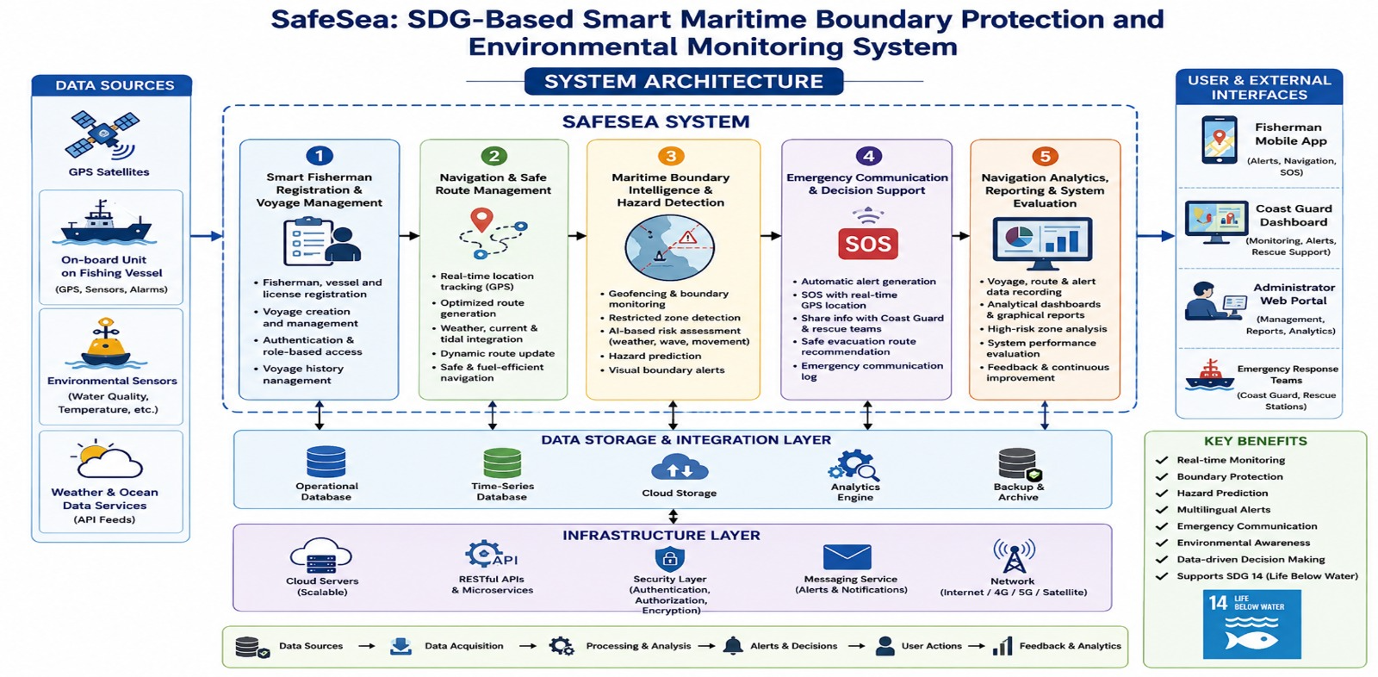

Figure 3.1: SafeSea System Architecture

The system can be organized into the following layers:

User Interface → Application/Business Logic → Navigation & Safety Services → Database

The User Interface allows fishermen, Coast Guard personnel and administrators to interact with the system.

The Application Layer manages authentication, user requests, voyage information and system operations.

Navigation and Safety Services process location information, route information, boundary conditions and emergency events.

The Database stores user, vessel, voyage, navigation and emergency records.

Systems Approach

The system components operate together through defined software interactions. User and vessel information is maintained before voyage operations begin. Navigation services provide location and route information, while boundary and hazard functions evaluate the navigation status and generate alerts when required. Emergency communication uses the available vessel and location information to support SOS notifications and response activities.

Essential Engineering Calculation

For boundary monitoring, the distance between the vessel and a defined boundary point can be estimated using geographical coordinates. A suitable distance calculation can be used to determine whether the vessel is approaching a restricted zone.

For example, using the Haversine equation:
$d=2R\sin^{-1}\left(\sqrt{\sin^{2}\frac{Δϕ}{2}+coscos ϕ_{1} coscos ϕ_{2} \sin^{2}\frac{Δλ}{2}}\right)$

where:

$d$= distance between two geographical points

$R$= Earth's radius

$ϕ$= latitude

$λ$= longitude

The calculated distance can be compared with a predefined safety threshold to generate a warning.

3.6 Trade-off Analysis

Design Decision | Alternative Considered | Benefit | Disadvantage | Final Decision & Justification
Integrated application | Separate applications | Centralized access and simpler workflow | Higher initial design effort | Selected because major safety functions are available in one system
OOAD architecture | Procedural design | Clear objects, classes and relationships | Requires detailed modelling | Selected because the project follows OOAD methodology
GPS-based monitoring | Manual position entry | More accurate and automated monitoring | Depends on location data availability | Selected because automated monitoring improves safety awareness
Role-based access | Common access for all users | Better security and controlled operations | Requires access-control design | Selected to separate Fisherman, Coast Guard and Administrator access
Email/SOS alerts | Manual emergency reporting | Faster communication | Depends on network/service availability | Selected for quicker emergency notification
Centralized voyage records | Manual records | Easy retrieval and analysis | Requires database storage | Selected for reliable voyage history

Table 3.6: Trade-off Analysis

3.7 Sustainability, Ethics, Safety, Risk & Security
Domain | Consideration | Evidence Evaluated | Impact on Final Decision
Sustainability | Reduce unnecessary navigation and improve route planning | Route-management and navigation requirements | Integrated route support was selected
Ethics | Protect fisherman and vessel information | User authentication and access requirements | Role-based access and controlled data handling were included
Health & Safety | Provide timely awareness of boundaries and hazards | Boundary and emergency requirements | Warning and SOS features were included
Security | Prevent unauthorized access to system information | Authentication and role requirements | Secure login and role-based authorization were included

Table 3.7: Sustainability, Ethics, Safety and Security Considerations

Risk Register
Risk | Likelihood | Severity | Risk Level | Mitigation | Residual Risk
GPS/location data unavailable | Medium | High | High | Display data status and avoid relying on unavailable location information | Medium
Network connectivity failure | Medium | High | High | Provide clear connection status and retain available records | Medium
Incorrect boundary information | Low | High | High | Use validated boundary data and regular data verification | Low
False or delayed alert | Medium | High | High | Test alert conditions and maintain clear warning thresholds | Medium
Unauthorized user access | Medium | High | High | Authentication and role-based access control | Low
Database failure | Low | High | Medium | Regular backup and error handling | Low
User misunderstanding of warning | Medium | High | High | Use clear messages, warning indicators and simple interface design | Medium
System software failure | Low | Medium | Medium | Functional testing, validation and error handling | Low

Table 3.8: SafeSea Risk Register

Security Measures

SafeSea incorporates basic security measures to protect system information:

Authentication – users must log in before accessing protected functions.

Role-Based Access Control – access is provided according to the user's role.

Input Validation – user inputs are checked before processing.

Protected User Data – personal and vessel information is not exposed to unauthorized users.

Session Management – authenticated access is controlled through appropriate session mechanisms.

Error Handling – system errors are handled without exposing unnecessary internal information.

Safety Consideration

SafeSea is designed as a decision-support and navigation-awareness system. Its alerts and route recommendations assist users but should not be treated as a replacement for official maritime navigation equipment, Coast Guard instructions, or established emergency procedures. This limitation is important because navigation decisions may depend on real-time conditions and external information availability.

CHAPTER 4

IMPLEMENTATION, TESTING & RESULTS, PROJECT MANAGEMENT

4.1 Development Approach & Resources

SafeSea was developed using an object-oriented software development approach based on Object-Oriented Analysis and Design (OOAD). The system was first analysed by identifying actors, requirements, use cases, classes, objects, and their relationships. The design was then converted into software components for user management, voyage management, navigation, safety monitoring, emergency communication, and reporting. The developed functions were tested individually and as complete workflows to verify that they satisfy the defined requirements.

Resources Used
Resource | Purpose
OOAD models | System analysis and design
GPS/Location data | Vessel position monitoring
Digital map/navigation data | Route and navigation support
Database | Storage of user, vessel, voyage and alert records
Web interface | User interaction and system monitoring
Development environment | Software implementation and testing

Table 4.1: Resource Used

4.2 Hardware / Software / Fabrication Implementation & Modern Tools Used

Software Implementation

SafeSea is primarily a software-based system. The implementation focuses on providing a user interface, application logic, database management, navigation monitoring, boundary detection, alerts, emergency communication, and analytics.

No physical fabrication or dedicated hardware prototype is required for the software implementation. Navigation information is handled through available location and map data.

Tools Used
Tool / Software / Equipment | Purpose | Stage Used
VS Code | Source-code development and editing | Implementation
React.js | Development of the user interface | Implementation
JavaScript | Application functionality and interaction | Implementation
Flask | Backend/API development | Implementation
MongoDB | Storage of system records | Implementation
Git/GitHub | Version control and source-code management | Development
Browser Developer Tools | Interface debugging and testing | Testing
Postman | API testing and verification | Testing

Table 4.2: Tools Used

Implementation Evidence

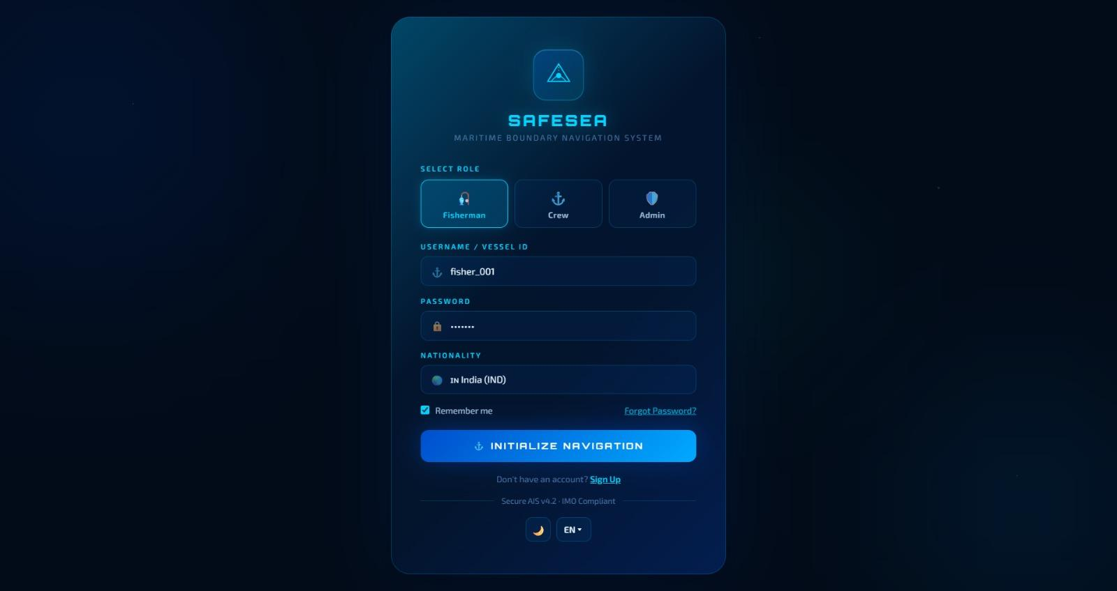

Figure 4.1: Login Page

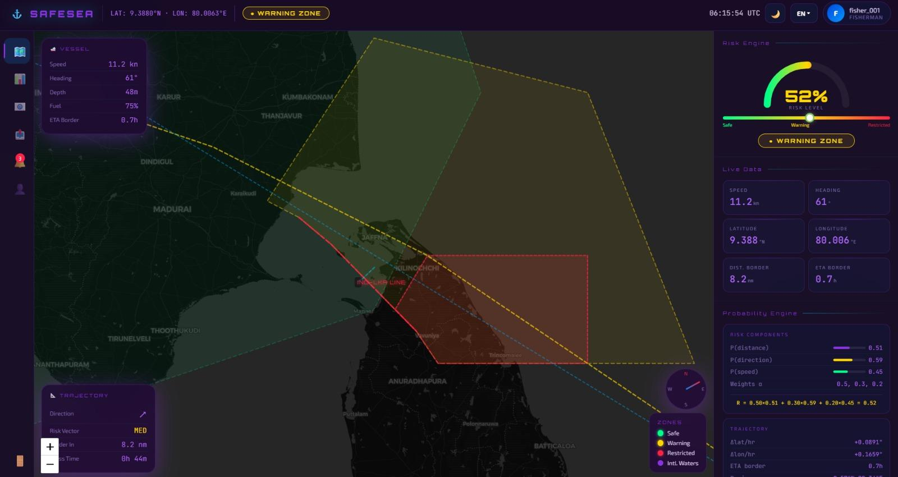

Figure 4.2: Dashboard Page

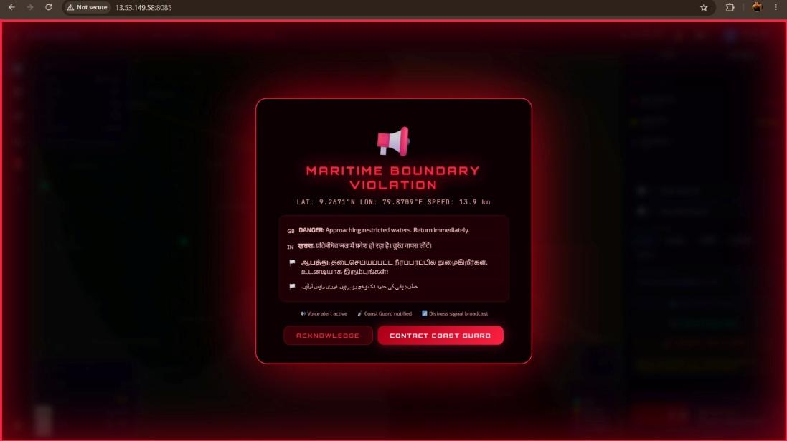

Figure 4.3: Danger Alert

4.3 Test Plan & Verification

Test Plan

The SafeSea system was tested using functional and workflow-based testing. Each major requirement was mapped to a test method and an acceptance criterion. Testing was performed to verify registration, authentication, voyage management, navigation monitoring, boundary detection, emergency communication, and reporting functions.

Functional Test Plan
Requirement | Test Method | Acceptance Criterion
User registration | Enter valid user details and submit | User account created successfully
User login | Enter valid credentials | User is authenticated successfully
Voyage management | Create and update voyage details | Voyage information stored correctly
Location monitoring | Provide valid location data | Vessel position displayed correctly
Boundary detection | Test vessel position near restricted area | Appropriate warning generated
Hazard detection | Provide hazard condition | Hazard warning displayed
Safe route management | Select navigation destination | Suitable route information displayed
SOS communication | Trigger emergency function | SOS information generated successfully
Navigation history | Open previous voyage records | Stored voyage information displayed
Role-based access | Login using different user roles | Only authorized functions are accessible

Table 4.3: Functional Test Plan

Specification Verification
Specification | Required Value | Achieved Value | Status
User authentication | Successful authentication | Successfully implemented | Pass
User registration | Valid details stored | Successfully implemented | Pass
Voyage management | Create/update voyage | Successfully implemented | Pass
Navigation monitoring | Vessel position displayed | Successfully implemented | Pass
Boundary detection | Warning for restricted area | Successfully implemented | Pass
Hazard notification | Hazard warning displayed | Successfully implemented | Pass
SOS communication | Emergency information generated | Successfully implemented | Pass
Role-based access | Authorized access only | Successfully implemented | Pass
Navigation records | Previous records retrievable | Successfully implemented | Pass

Table 4.4: Specification Verifiction

4.4 Results

The developed SafeSea prototype was evaluated using functional testing of the major system operations. The tests confirmed that the implemented functions operated according to their intended requirements.

Test Results Summary

Test Category | Tests Performed | Passed | Status
Registration & Login | 2 | 2 | Pass
Voyage Management | 2 | 2 | Pass
Navigation Monitoring | 2 | 2 | Pass
Boundary & Hazard Detection | 2 | 2 | Pass
Emergency Communication | 1 | 1 | Pass
Access Control | 1 | 1 | Pass
Total | 10 | 10 | Pass

Table 4.5: Test Result Summary

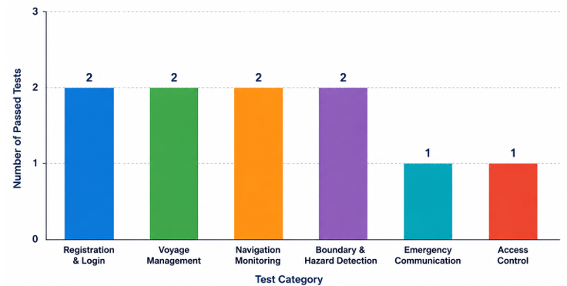

Figure 4.4: SafeSea Functional Testing Results

4.5 Data Analysis & Engineering Judgment

The testing results indicate that the major SafeSea functions operated according to their defined requirements. Registration and authentication successfully controlled user access, while voyage and navigation functions supported the management and monitoring of vessel activities. Boundary and hazard detection provided safety notifications, and the emergency function generated the required SOS information.

The results also indicate that SafeSea provides better integration than using independent functions separately. However, actual navigation accuracy depends on the quality and availability of external location, map, network, and maritime information. Therefore, the prototype should be considered a software decision-support system rather than a replacement for certified maritime navigation and emergency systems.

4.6 Comparison with Existing Solutions & Achievement of Objectives
Objective | Evidence | Achievement
Design the system using OOAD principles | Use case, class and activity models | Fully Achieved
Develop registration and voyage management | Registration, login and voyage functions | Fully Achieved
Implement navigation monitoring | Navigation/location interface | Fully Achieved
Provide boundary and hazard detection | Boundary and hazard alerts | Fully Achieved
Implement emergency communication | SOS/emergency functionality | Fully Achieved
Develop navigation analytics and reporting | Analytics and reporting interface | Fully Achieved
Test and evaluate system functions | Functional and workflow testing | Fully Achieved

Table 4.6: Achievement of Project Objectives

4.7 Strengths & Limitations

Strengths

Integrates major maritime safety functions into one system.

Provides vessel navigation and location awareness.

Supports restricted-area and hazard alerts.

Provides emergency/SOS communication support.

Uses role-based access for different users.

Maintains voyage information for later review.

OOAD-based structure supports future system expansion.

Provides a simple user-oriented interface.

Limitations

System performance depends on GPS/location data availability.

Network connectivity may affect real-time communication.

The prototype does not replace certified maritime navigation systems.

Accuracy depends on the quality of available map and boundary data.

The current system has limited physical hardware integration.

Large-scale real-world deployment requires additional validation.

4.8 Project Planning, Roles & Budget

Project Milestone Timeline
Phase | Major Activities
Phase 1 | Problem identification and requirement analysis
Phase 2 | Literature review and existing-system analysis
Phase 3 | OOAD modelling and system design
Phase 4 | Interface and backend development
Phase 5 | Navigation, boundary and emergency functionality
Phase 6 | Integration and database implementation
Phase 7 | Testing and debugging
Phase 8 | Final evaluation and report preparation

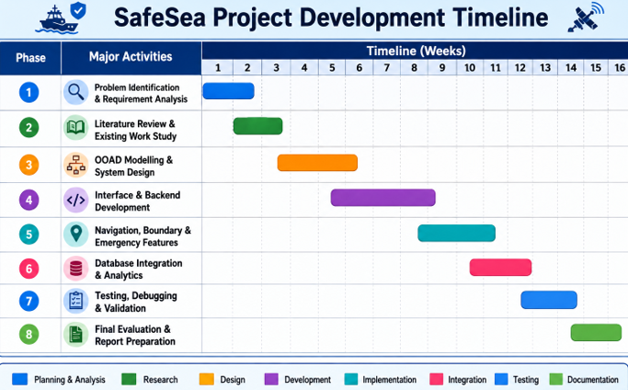

Figure 4.5: SafeSea Project Development Timeline

Team Roles and Contributions
Student | Assigned Responsibility | Actual Contribution
Tejaswini M (192411079) | Navigation and safe route management | Developed navigation interface, route-management functions and contributed to testing and documentation
Sharu Priya M (192411116) | Fisherman registration and voyage management | Developed registration, authentication and voyage-related functions and contributed to documentation
Vishalsai BJ (192320012) | Boundary monitoring and emergency communication | Developed boundary detection, alerts and emergency communication functions and contributed to testing
D Chaitanya (192320028) | Navigation analytics and system evaluation | Developed analytics/reporting functions and contributed to system evaluation, OOAD diagrams and documentation

Table 4.7: Team Roles & Contribution

Project Budget

Item | Estimated Cost | Actual Cost
Software Development Tools | ₹500 | ₹0
Cloud/Database Services | ₹500 | ₹0
Internet/Data | ₹500 | ₹300
Prototype & Documentation | ₹500 | ₹300
Total | ₹2,000 | ₹600

Table 4.8: Project Budget

CHAPTER 5
CONCLUSION, FUTURE WORK AND REFLECTION

5.1 Conclusion
SafeSea was developed to address the challenges faced by fishermen in navigation, maritime boundary awareness, hazard identification, and emergency communication. The system provides an integrated software solution for fisherman registration, voyage management, navigation monitoring, safe route management, boundary and hazard detection, emergency communication, and navigation analytics.
The system was designed using Object-Oriented Analysis and Design (OOAD) principles. Use case, class, activity, and system design models were used to represent the users, system objects, relationships, and interactions. The implementation provided a structured platform where fishermen can manage voyage information, monitor navigation status, receive safety alerts, and initiate emergency communication when required.
Functional and workflow-based testing was performed for the major system operations. The testing results showed that the implemented functions operated according to their intended requirements, including registration, authentication, voyage management, navigation monitoring, boundary detection, alerts, emergency communication, and access control.
Overall, SafeSea demonstrates the application of OOAD principles to a practical maritime safety problem. The project provides a foundation for developing a more comprehensive maritime decision-support system with improved navigation awareness, safety monitoring, emergency response, and future real-time integration.

5.2 Future Work
The following improvements can be considered for future development:
- Integration with real-time GPS/GNSS devices for continuous vessel tracking.
- Integration of real-time weather, wave, tide, and ocean-current data.
- Improved route optimization using live maritime conditions.
- Integration with official maritime boundary and restricted-zone databases.
- Development of a dedicated mobile application for fishermen.
- Integration of additional emergency communication channels such as SMS and push notifications.
- Addition of offline functionality for areas with poor network connectivity.
- Integration with physical maritime safety equipment and vessel monitoring devices.
- Improved analytics for voyage history, route performance, and safety events.
- Deployment and evaluation with real-world maritime users under controlled conditions.
5.3 Professional Learning & Individual Reflection
New Knowledge Acquired
- Learned the application of Object-Oriented Analysis and Design (OOAD) in a real-world software project.
- Learned how to identify actors, use cases, classes, objects, relationships, and system interactions.
- Gained knowledge of navigation monitoring, boundary detection, and emergency communication workflows.
- Learned how to connect frontend, backend, and database components.
- Gained practical experience in software testing, debugging, documentation, and project management.
Engineering & Professional Skills Developed
- Requirements analysis and system modelling.
- Object-oriented software design.
- Full-stack software development.
- Database design and management.
- Functional testing and debugging.
- Technical documentation and report preparation.
- Team collaboration and task coordination.
- Problem-solving and engineering decision-making.
- Project planning and progress tracking.

Individual Reflection – Tejaswini M
Register No.: 192411079
The main challenge I encountered was designing the navigation and route-management functions in a way that was simple for users to understand. I addressed this by organizing the navigation workflow clearly and connecting it with the required location information. A key engineering decision was to provide navigation information through a structured interface rather than presenting complex information directly to the user. I independently improved my understanding of navigation interfaces and OOAD modelling. If the project were repeated, I would improve the real-time navigation and route optimization features.

Individual Reflection – Sharu Priya M
Register No.: 192411116
The most difficult problem I encountered was managing user registration, authentication, and voyage information consistently. This was addressed by separating user-related operations and applying controlled access to system functions. A key decision was to use role-based access so that different users could access only the functions relevant to them. I gained additional knowledge of authentication, database operations, and software requirements analysis independently. If the project were repeated, I would improve the authentication mechanism and provide more detailed user-management features.

Individual Reflection – Vishalsai BJ
Register No.: 192320012
The main engineering challenge was implementing boundary monitoring, safety alerts, and emergency communication in a reliable workflow. I addressed this by defining clear conditions for generating warnings and organizing emergency information so that it could be communicated effectively. A key decision was to include immediate alert generation when a safety condition was detected. I developed new knowledge about geofencing concepts, alert handling, and emergency communication workflows. If the project were repeated, I would improve real-time boundary monitoring and integrate additional communication methods.

Individual Reflection – D Chaitanya
Register No.: 192320028
The main challenge was organizing navigation analytics and evaluating the overall system in a structured manner. I addressed this by defining relevant records and presenting the required information through reports and analytical views. A key engineering decision was to use structured system data for reviewing navigation activities and evaluating system performance. I gained additional knowledge of software evaluation, analytics, OOAD diagrams, and technical documentation. If the project were repeated, I would improve the analytics with more detailed performance indicators and real-time reporting.

REFERENCES

A. Literature References
[1] A. Troupiotis-Kapeliaris, C. Kastrisios, and D. Zissis, “Vessel Trajectory Data Mining: A Review,” IEEE Access, vol. 13, pp. 4827–4856, 2025, doi: 10.1109/ACCESS.2025.3525952.
[2] N. Kutin, R. Bucknall, P. Wu, and Y. Liu, “Vessel Trajectory Classification from a Graph Network Perspective,” Advanced Engineering Informatics, vol. 69, Art. no. 104082, 2026, doi: 10.1016/j.aei.2025.104082.
[3] J. Wang, L. Jiao, and Q. Pan, “Vessel Trajectory Recognition Based on Multi-Source Data Multi-Stage Fusion,” IEEE Sensors Journal, 2026, doi: 10.1109/JSEN.2026.3658076.
B. Standards
[4] ISO/IEC, ISO/IEC 25010:2023 — Systems and Software Engineering — Systems and Software Quality Requirements and Evaluation (SQuaRE) — Product Quality Model, ISO, Geneva, Switzerland, 2023.
[5] ISO/IEC, ISO/IEC 27001:2022 — Information Security, Cybersecurity and Privacy Protection — Information Security Management Systems — Requirements, ISO, Geneva, Switzerland, 2022.
[6] IEEE, IEEE Standard for System, Software and Hardware Verification and Validation, IEEE Std. 1012-2016, 2016.
C. Main Website/Software References
[7] Mozilla Developer Network, “JavaScript Guide,” MDN Web Docs, 2026.
[8] React Team, “React Documentation,” React, 2026.
[9] Pallets Projects, “Flask Documentation,” Flask, 2026.
[10] MongoDB, Inc., “MongoDB Documentation,” MongoDB Documentation, 2026.
APPENDICES

Appendix A – Detailed Calculations
A.1 Haversine Distance Calculation
The Haversine formula is used in SafeSea to calculate the distance between the vessel's current GPS position and a reference maritime boundary point.
$d=2R\sin^{-1}\left(\sqrt{\sin^{2}\left(\frac{Δϕ}{2}\right)+coscos ϕ_{1} coscos ϕ_{2} \sin^{2}\left(\frac{Δλ}{2}\right)}\right)$
Where:
- $d$= distance between two locations
- $R$= radius of Earth
- $ϕ_{1},ϕ_{2}$= latitudes
- $λ_{1},λ_{2}$= longitudes
- $Δϕ$= difference in latitude
- $Δλ$= difference in longitude
The calculated distance is compared with the predefined safety threshold. If the vessel approaches a restricted or hazardous area, the system generates an appropriate warning.

Appendix B – Engineering Drawings / Schematics
The following OOAD and system design diagrams are included:
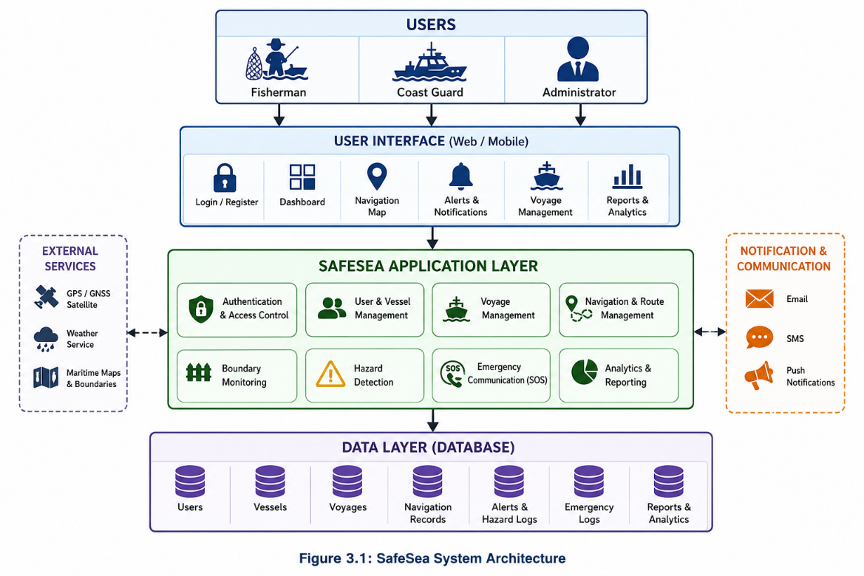
Figure B.1: SafeSea System Architecture

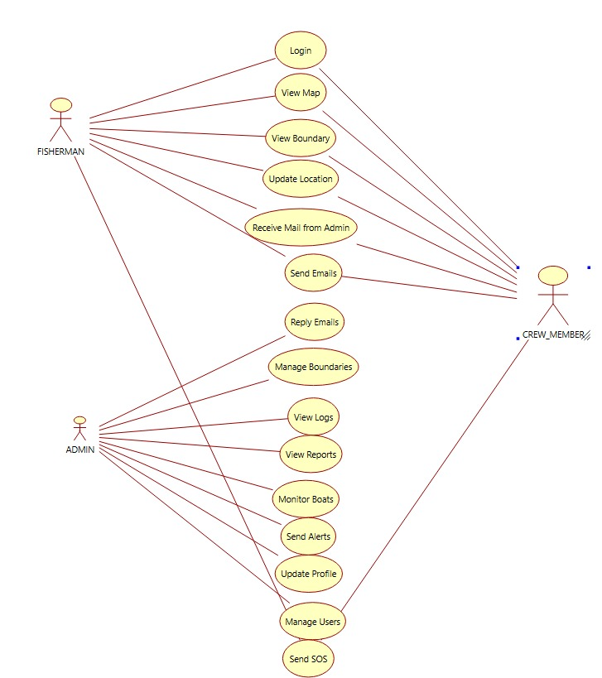
Figure B.2: SafeSea Use Case Diagram
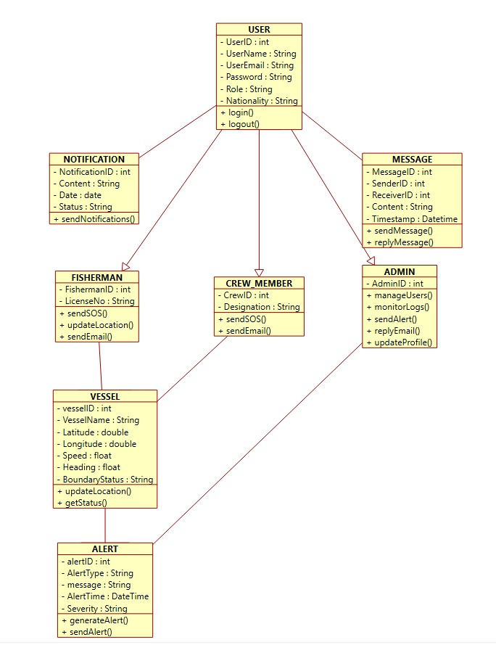
Figure B.3: SafeSea Class Diagram
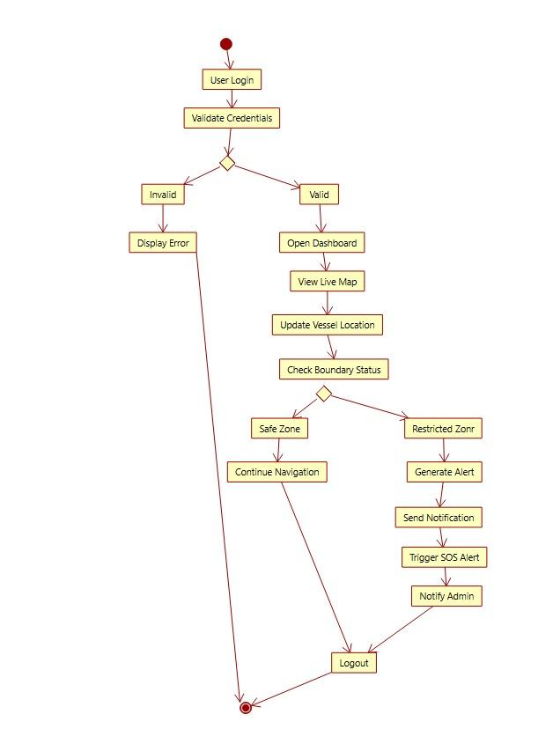
Figure B.4: SafeSea Activity Diagram

Appendix C – Source Code / Code Repository Information
The SafeSea system source code is maintained separately in the approved project repository.
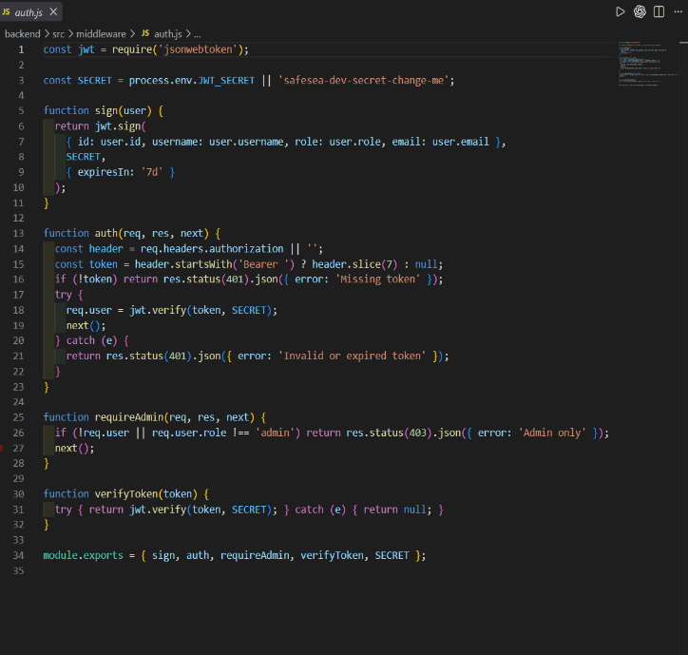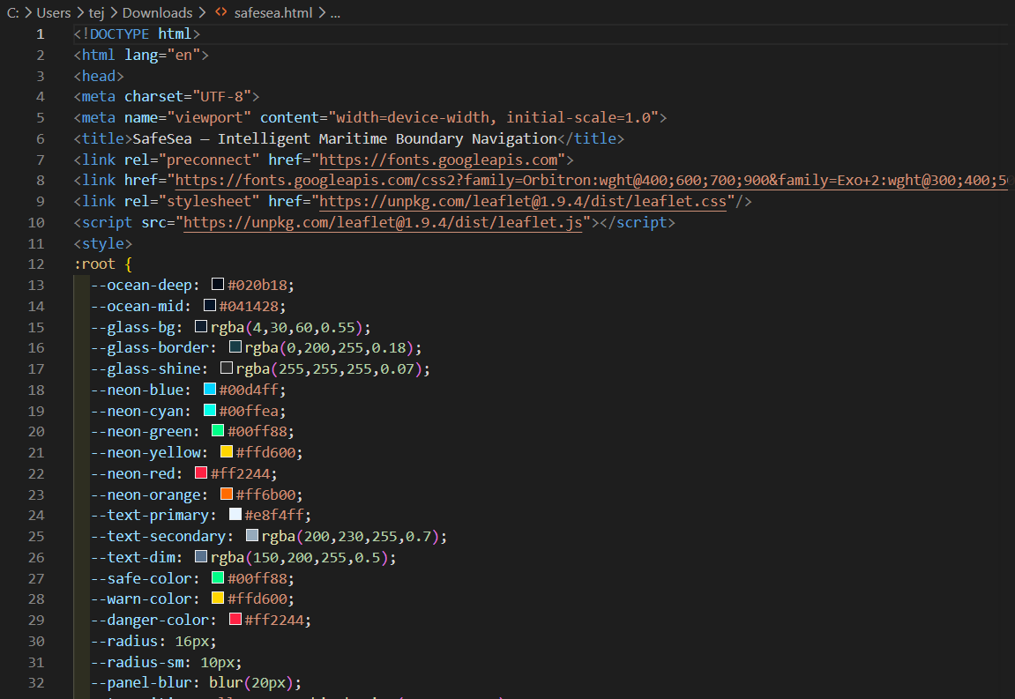
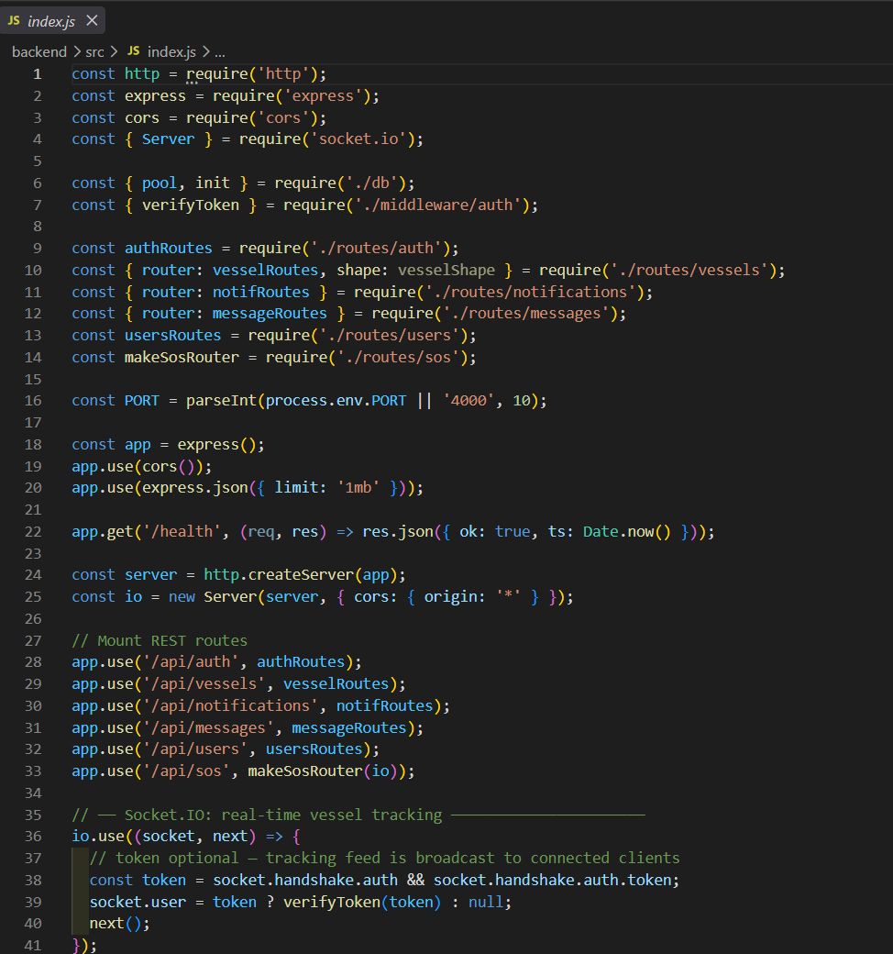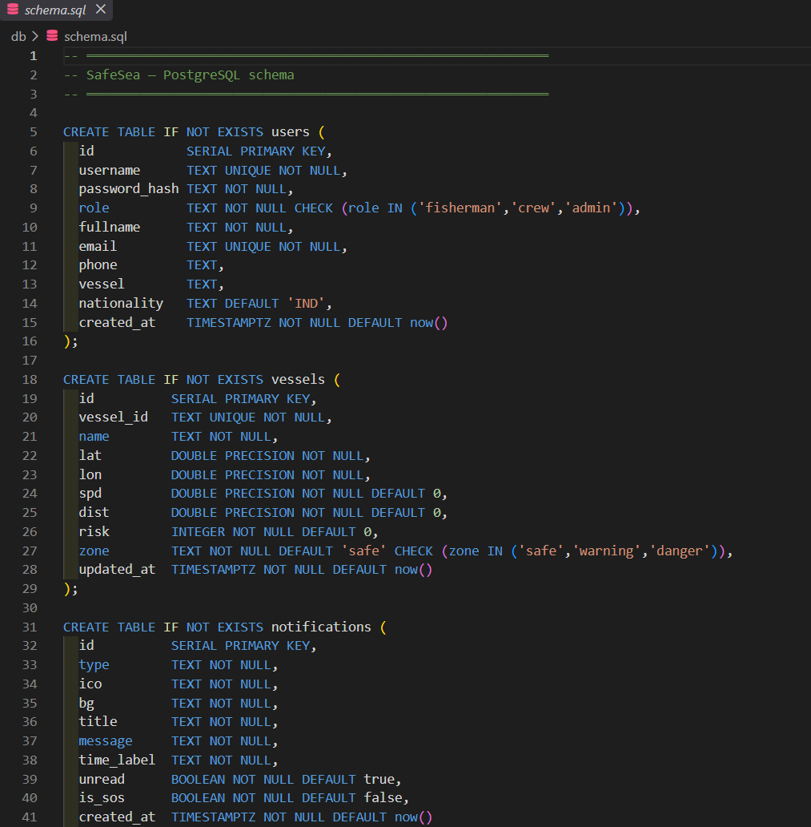

Technologies Used
Component | Technology
Frontend | React.js, JavaScript
Backend | Flask
Database | MongoDB
API Testing | Postman
Development | Visual Studio Code
Version Control | Git/GitHub

Appendix D – Experimental / Raw Data
The following functional testing records were used to evaluate the SafeSea system.
Test Category | Tests Performed | Passed | Result
Registration & Login | 2 | 2 | Pass
Voyage Management | 2 | 2 | Pass
Navigation Monitoring | 2 | 2 | Pass
Boundary & Hazard Detection | 2 | 2 | Pass
Emergency Communication | 1 | 1 | Pass
Access Control | 1 | 1 | Pass
Total | 10 | 10 | Pass

Appendix E – Ethics / Institutional Approval
SafeSea is a software-based academic project developed for educational purposes. The system does not involve human subjects, medical experiments, animal testing, or collection of sensitive research data for experimental purposes.
User and vessel information used within the system is intended to be handled through authentication and role-based access control.

Appendix F – Project Meeting / Progress Records
The project progress was reviewed through regular team discussions covering:
- Requirement identification
- Literature review
- OOAD modelling
- System architecture
- Module development
- Database integration
- Testing and debugging
- Final evaluation
- Report preparation

Progress Summary
Phase | Major Activity | Status
1 | Problem Identification & Requirements | Completed
2 | Literature Review | Completed
3 | OOAD Modelling & Design | Completed
4 | Interface & Backend Development | Completed
5 | Navigation, Boundary & Emergency Features | Completed
6 | Database Integration & Analytics | Completed
7 | Testing & Validation | Completed
8 | Final Evaluation & Documentation | Completed

Appendix G – Individual Contribution Evidence

This appendix is mandatory because SafeSea is a team project.
Student | Contribution Area | Evidence
Tejaswini M (192411079) | Navigation and Safe Route Management | Navigation interface, route-management functions, testing and documentation
Sharu Priya M (192411116) | Fisherman Registration and Voyage Management | Registration, authentication, voyage functions and documentation
Vishalsai BJ (192320012) | Boundary Monitoring and Emergency Communication | Boundary detection, alerts, emergency communication and testing
D Chaitanya (192320028) | Navigation Analytics and System Evaluation | Analytics, reporting, evaluation, OOAD diagrams and documentation

CAPSTONE PROJECT OUTCOME MAPPING SHEET

To be completed by the department/faculty assessor.

Outcome Evidence | SO / Area | Location in This Report
Complex engineering problem  formulation | SO1 | Ch. 1, Ch. 2
Engineering design under constraints | SO2 | Ch. 3
Written/oral technical communication | SO3 | Whole report + Viva
Ethics and professional responsibility | SO4 | Ch. 3 (3.7)
Teamwork and leadership | SO5 | Ch. 4 (4.8)
Experimentation, analysis, engineering  judgment | SO6 | Ch. 4 (4.3–4.6)
Independent acquisition of new  knowledge | SO7 | Ch. 5 (5.3)
Standards | SO2 | Ch. 3 (3.2)
Sustainability and  societal/environmental impact | SO2/SO4 | Ch. 3 (3.7)
Risk assessment and mitigation | SO2/SO4 | Ch. 3 (3.7)
Security considerations | Relevant SO | Ch. 3 (3.7)
Integrated/system-level engineering | SO1/SO2 | Ch. 3 (3.5)
Project planning and management | SO5 | Ch. 4 (4.8)
Individual contribution | SO1–SO7 | Contribution Statement + Ch. 4  (4.8)

